J12. ARISTOPHOT SERIES. [1906]

Pu Aristophot London

Three Formats used:
40A. Pr In Taucha
F Small sepia-toned Photo inserted in coloured picture of the New South
Wales State Flag. This is merely one of the Flag series of over 400 cards,
each with a view or portrait inset upon a British or Colonial flag. All were
issued in 1906. (Byatt, 1978 : 32)

40A.1 The Willows, Jenolan Caves H [pm.22 Dec.1906]

40B & 40C.

Pr In Saxony
F Two small pictures in art nouveau background with "Greetings from New South Wales" in
large letters.

In sepia real photo (B)
40B.1 The Willows, Jenolan Caves H (also 'Cabbage Palms in the Illawarra District V)

In full colour (C)
40C.1 The Willows, Jenolan Caves H (also 'Cabbage Palms in the Illawarra District V) [pm.4 Oct 1907]

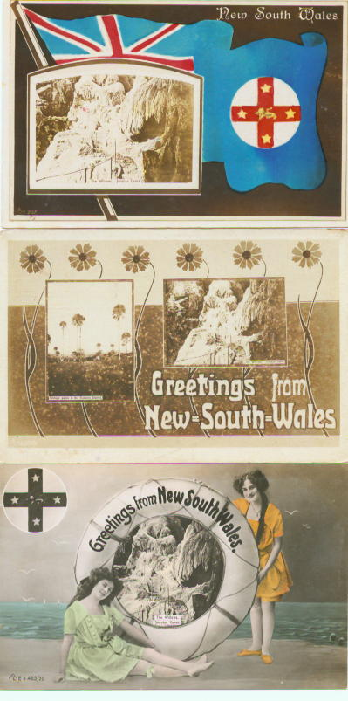

40D
Pr In Saxony
F Two young women in bathing costumes hold a ship's lifebuoy, inscribed 'Greetings from New South Wales', with picture inside the lifebelt, all against a beachside background. Coloured.

40D.1 The Willows/Jenolan Caves H

